***Database Project (FinalTerm)***

**Topic: University Management System**

**Group Members:**

1.Md. Shakibur Rahman (ID: 20-42723-1)

2.Dil Mahmud Khan (ID: 20-42199-1)

3.Atiqul Islam Utsha (ID: 20-42999-1)

4.Md. Maruf Mia (ID: 19-41786-3)

***University Management System***

We have to maintain some procedure to draw the ER-Diagram for University Management System.

*The admission examiner takes exams for admission test to admit students every year. Each examiner has unique E_serial,E_name and E_Number.

*After the admission test some students are qualified for the university. They have QF_id,QF_name and payment for the admission.

*There will be a relation for the admission.

*Student has SID, Name, Age and City.

*Students enrolls for class and it has C_no, Schedule and class capacity 40.

*Grading system will be there and it contains courseno, course name, Marks and CGPA which is is not more than 4.

*Faculty will be working for department. They teach in class.

*Department has unique DID and D_Name. Faculty has unique F_ID and F_Name . Faculty has a special skill.

*Enrolling in the class for student will be individually.

*Faculty takes class individually. One department may have many faculties.

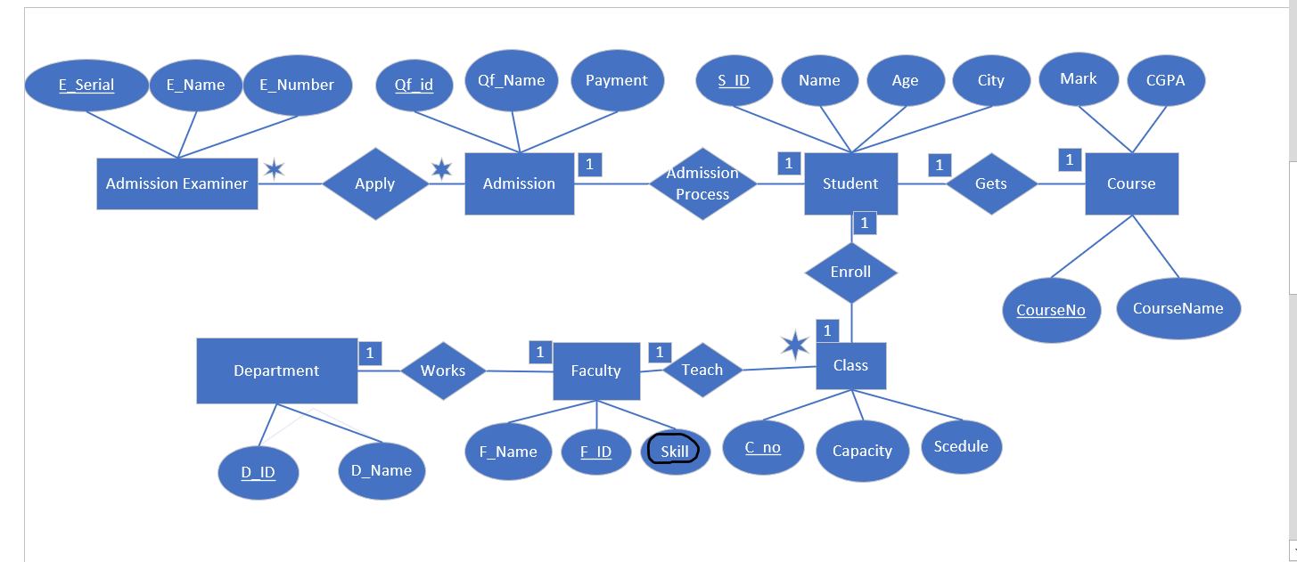

Apply(E_Serial,E_Name,E_Number,Qf_id,Qf_Name,Payment)

1NF: No multivalued attributes

2NF: E_Serial,E_Name,E_Number

Qf_id,Qf_Name,Payment

3NF: There is no transitive dependency

E_Serial,E_Name,E_Number

Qf_id,Qf_Name,Payment

Final Table for Apply:

1. E_Serial,E_Name,E_Number

2. Qf_id,Qf_Name,Payment

3. N_id,E_Serial,Qf_id

Admission Process (Qf_id,Qf_name,payment,S_ID,Name,Age,City)

1NF: No Multivalues attributes

2NF: Qf_id,Qf_name,payment

S_ID,Name,Age,City

3NF: No transitive dependency

Qf_id,Qf_name,payment

S_ID,Name,Age,City

Final Table for Admission Process:

1. Qf_id,Qf_name,payment,S_ID

2. S_ID,Name,Age,City

Enroll(S_ID,Name,Age,City,C_No,Capacity,Scedule)

1NF: No multivalued attributes

2NF: S_ID,Name,Age,City

C_No,Capacity,Schedule

3NF: No Transitive dependency

S_ID,Name,Age,City

C_No,Capacity,Schedule

Final Table for Enroll:

1. S_ID,Name,Age,City

2. C_No,Capacity,Schedule,S_ID

Gets(S_ID,Name,Age,City,Course_no,course_Name,Mark,Cgpa)

1NF: No multivalued attributes

2NF: S_ID,Name,Age,City

Course_no,course_Name,Mark,Cgpa

3NF: S_ID,Name,Age,City

Course_no,Course_Name

Course_Serial,Mark,Cgpa

Final Table for Gets:

1.S_ID,Name,Age,city Course_no

2. Course_no,Course_Name,Course_Serial

3. Course_Serial,Mark,Cgpa

Teach (C_no, Schedule, Capacity, F_ID, F_Name, Skill)

1NF: Skill is a multivalued attribute

2NF: C_no, Schedule, Capacity

F_ID, F_Name, Skill

3NF: C_no, Schedule, Capacity

F_ID, F_Name, Skill

Final Table for Teach:

1. C_no, Schedule, Capacity

2. F_ID, F_Name

3.Skill, F_ID (Composite primary key)

Works (F_ID,F_name,skill,D_ID,D_Name)

1NF: Skill is multivalued attribute

2NF: F_ID,F_name,skill,

D_ID,D_Name

3NF: No transitive dependency

F_ID,F_name,skill,

D_ID,D_Name

Table for Works:

1. F_ID,F_name

2.D_ID, D_Name,F_ID

3.Skill, F_ID (Composite Primary Key)

FINAL TABLE FOR MANAGEMENT

1.E_Serial,E_Name,E_Number[Admission_Examiner]

2.N_id,E_Serial,Qf_id[Serial]

3. Qf_id,Qf_name,payment,S_ID[Admission]

4. C_No,Capacity,Schedule,F_ID,S_ID[Class]

5.S_ID, Name,Age,city Course_no[Student]

6. Course_no, Course_Name,Course_Serial[Course]

7. Course_Serial,Mark,Cgpa[Grade]

8.Skill, F_ID (Composite Primary Key)[Teach]

9.D_ID, D_Name,F_ID[Department]

10. F_ID,F_name[Faculty]

Table 1:

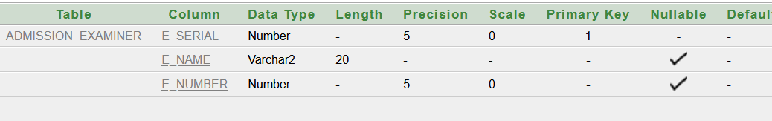

Table 2:

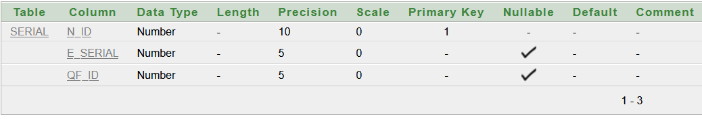

Table 3:

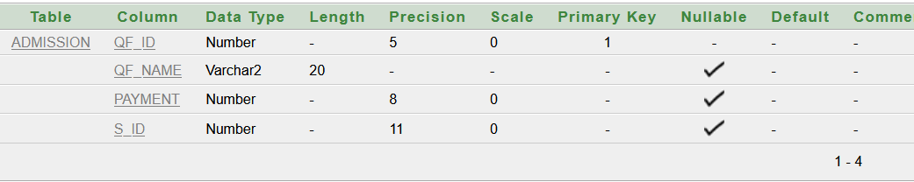

Table 4:

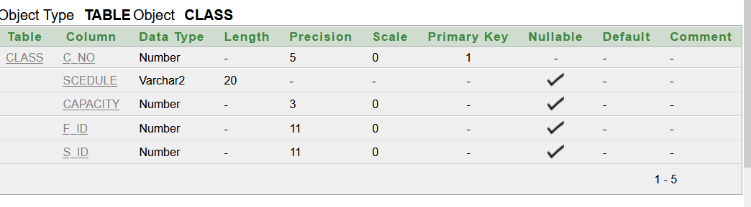

Table 5:

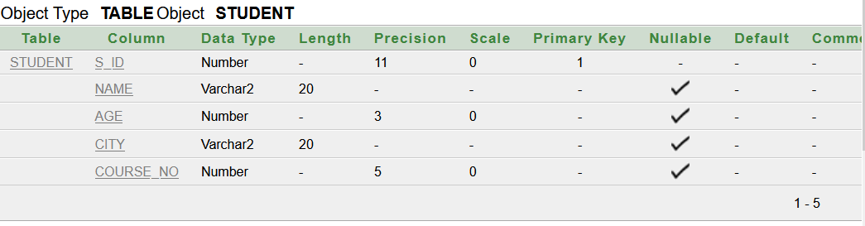

Table 6:

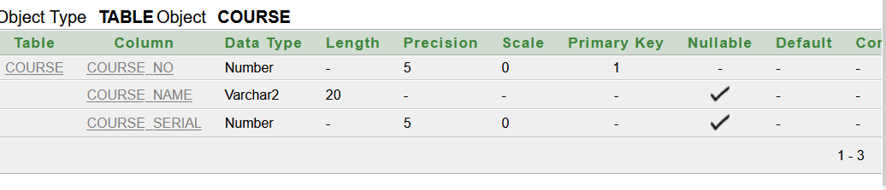

Table 7:

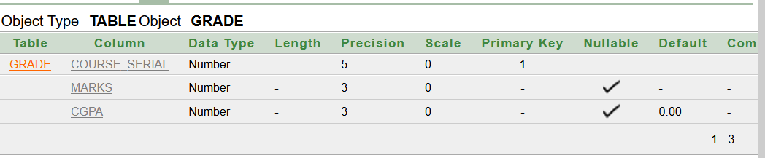

Table 8:

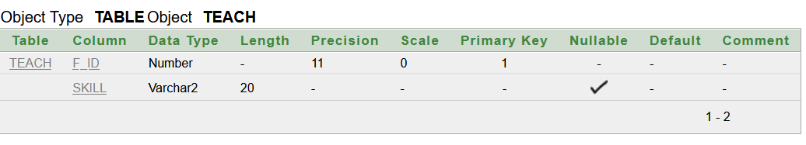

Table 9:

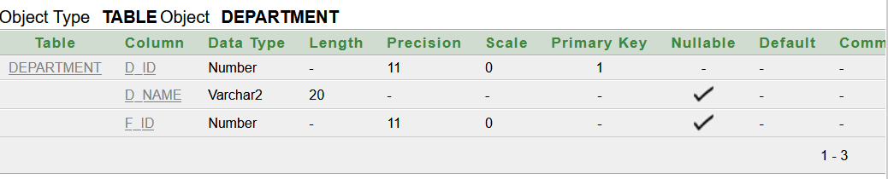

Table 10:

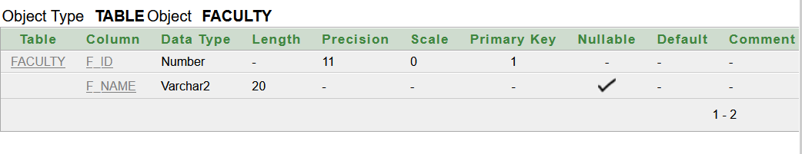

Value Table 1:

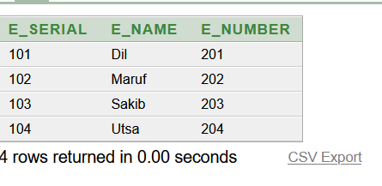

Value Table 2:

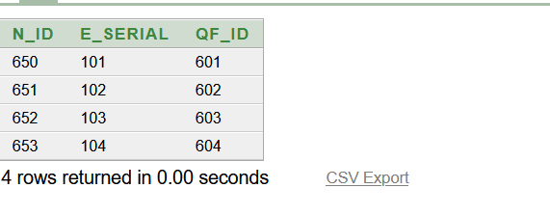

Value Table 3:

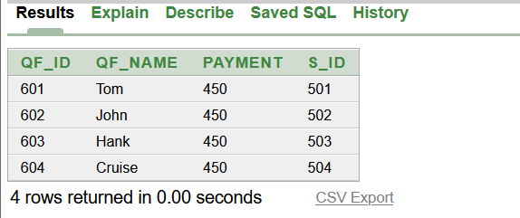

Value Table 4:

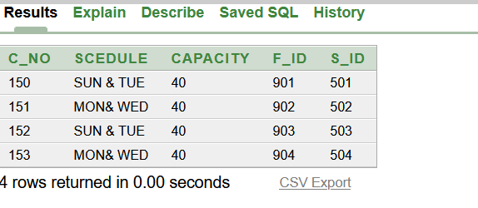

Value Table 5:

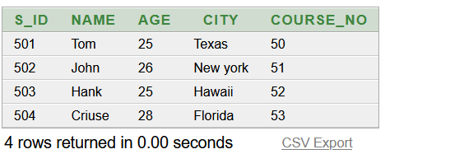

Value Table 6:

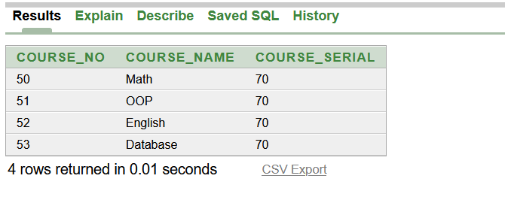

Value Table 7:

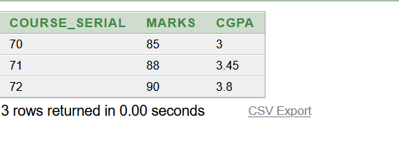

Value Table 8:

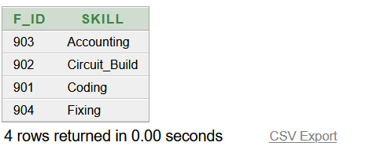

Value Table 9:

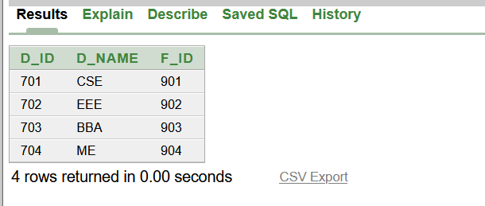

Value Table 10:

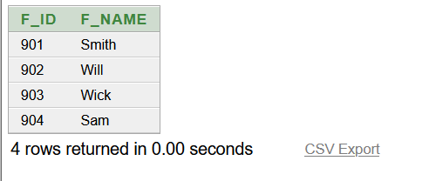

Questions:

1. Write a query to show the Qf_id, payment and SID of Tom from Admission table.
2. Show all the Students name of the table Admission Who paid taka 450.
3. Display the name,age,city of the students whose age is below 28.
4. Create a sequence where its name is Faculty_s increment by 1,Max value 300,starts with 100,no min value,no cache and no cycle.
5. Show the students name,course and S_ID who has a course database.( equi join)
6. Write a query to display all faculty id and department name. (outer join)
7. Display the cgpa where cgpa is less than 3.8 and greater than 3.
8. Create a view named Student_s that has SID,name,age,city where the course no is 52 .
9. Replace the column name to Student_Name.
10. Write a query of a Examiner whose seial number is 101.
11. Display the skill of a faculty whose faculty id is 901.